Solid

Definition
# Source: AI Source: Provided by: [Data Path: Persons Table -> ID Column: 1, Name_En Column: Motasem Essam] -> From: [ChatGPT] on [7/25/2026]
A Solid in Solid Geometry is a three-dimensional geometric object that occupies space and has length, width, and height. A solid is studied through its volume, boundary, surface area, and spatial properties.
Solids may be bounded by flat polygonal faces, curved surfaces, or a combination of both.

Simple Definition
# Source: AI Source: Provided by: [Data Path: Persons Table -> ID Column: 1, Name_En Column: Motasem Essam] -> From: [ChatGPT] on [7/25/2026]
A solid is a three-dimensional object that occupies space.
Examples include cubes, cuboids, spheres, cylinders, cones, prisms, and pyramids.
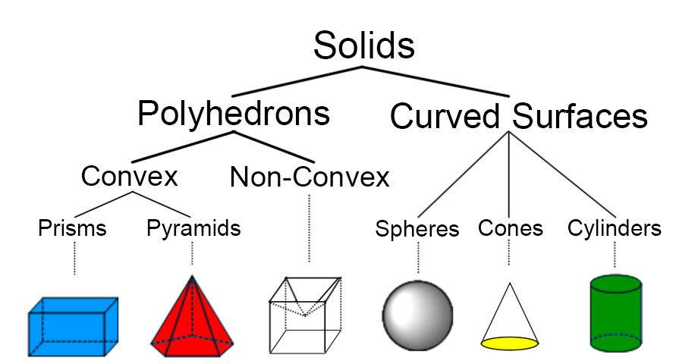
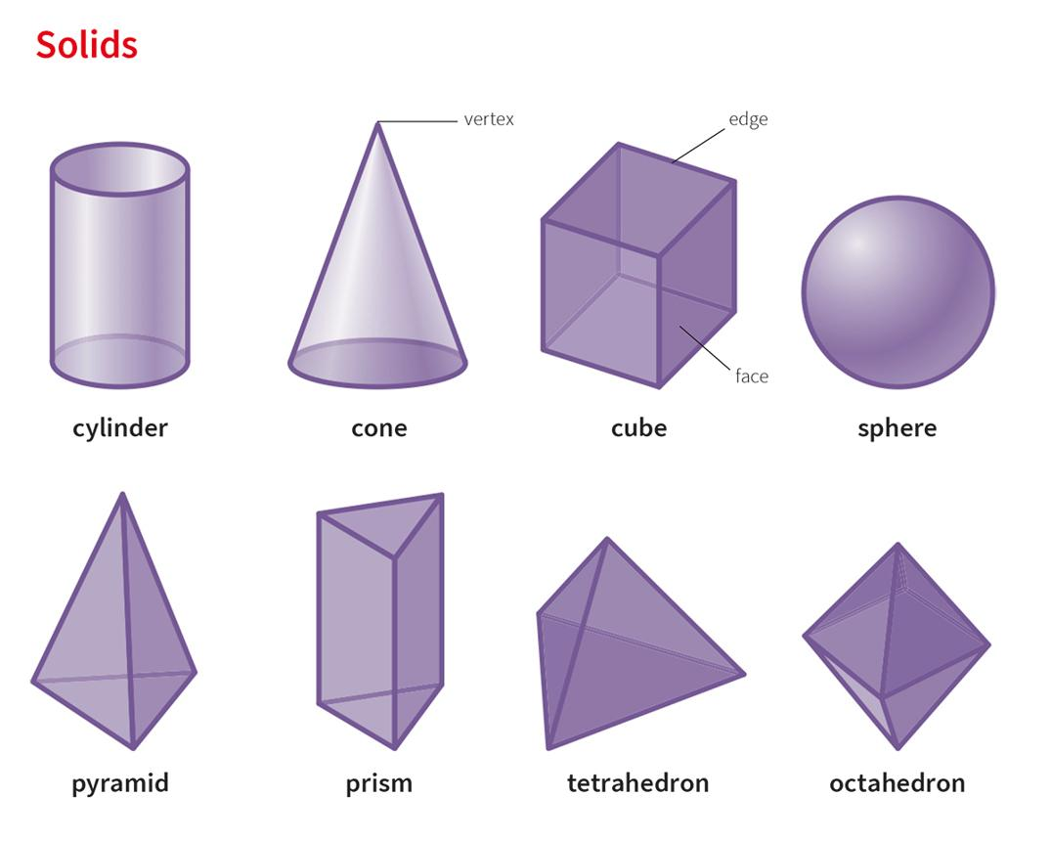
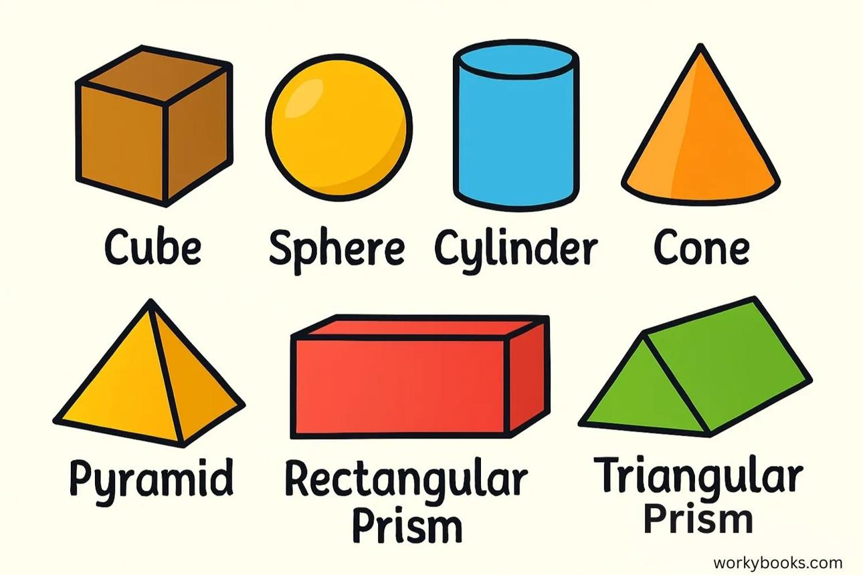

Fundamental Properties
# Source: AI Source: Provided by: [Data Path: Persons Table -> ID Column: 1, Name_En Column: Motasem Essam] -> From: [ChatGPT] on [7/25/2026]
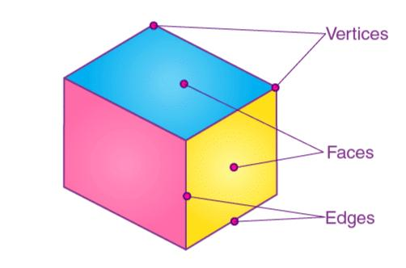
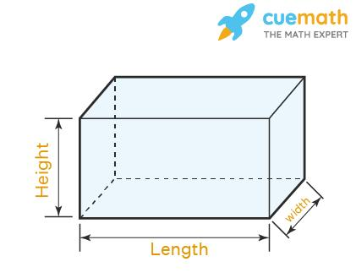
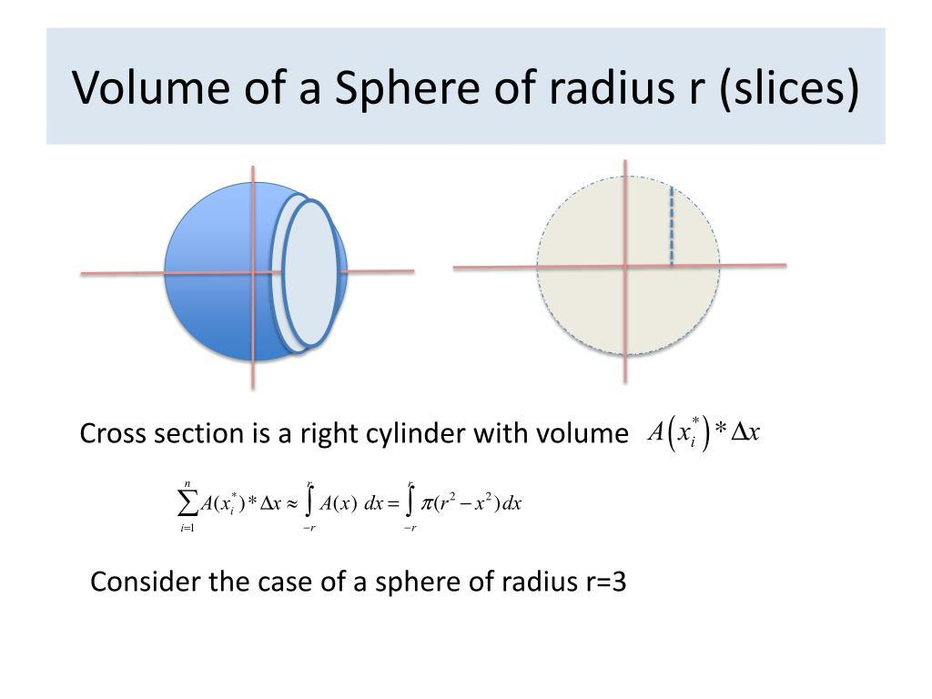
- Three-Dimensional: A solid has length, width, and height.
- Spatial Occupancy: A solid occupies a region of three-dimensional space.
- Volume: A solid has a measurable volume when its occupied region is measurable.
- Boundary: A solid has a boundary separating its interior from its exterior.
- Surface Area: For solids with sufficiently well-defined surfaces, the area of the boundary can be calculated.
- Interior and Exterior: Points can be classified as lying inside the solid, on its boundary, or outside it.

Main Types of Solids

1. Polyhedra
# Source: AI Source: Provided by: [Data Path: Persons Table -> ID Column: 1, Name_En Column: Motasem Essam] -> From: [ChatGPT] on [7/25/2026]
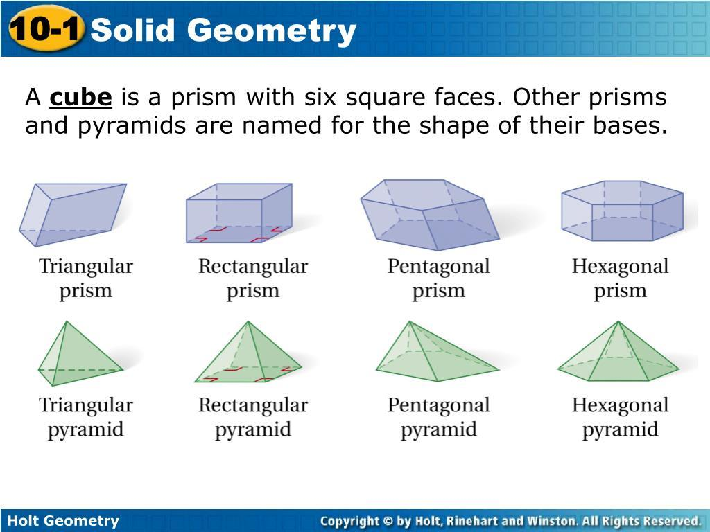
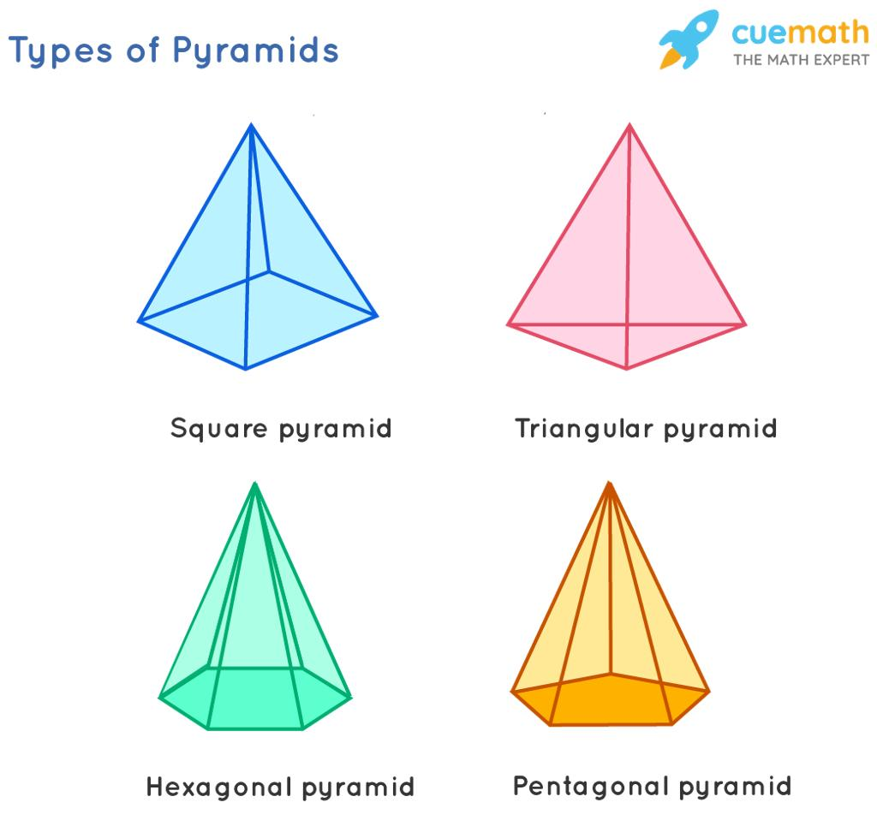
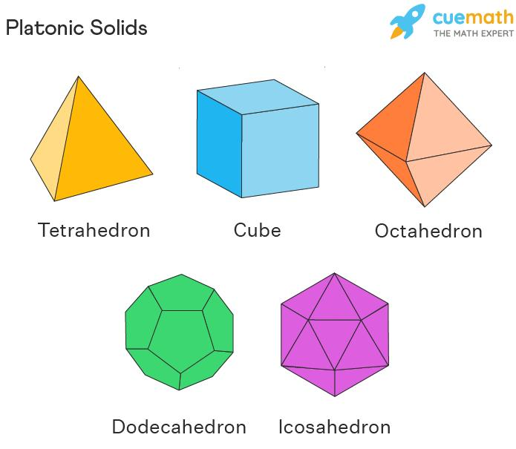
A polyhedron is a solid bounded by flat polygonal faces.
- Prisms: Have two congruent, parallel bases connected by side faces.
- Pyramids: Have one polygonal base and triangular side faces meeting at an apex.
- Platonic Solids: The five regular convex polyhedra: tetrahedron, cube, octahedron, dodecahedron, and icosahedron.
- Other Polyhedra: Include irregular, convex, and concave polyhedra.

2. Solids with Curved Surfaces
# Source: AI Source: Provided by: [Data Path: Persons Table -> ID Column: 1, Name_En Column: Motasem Essam] -> From: [ChatGPT] on [7/25/2026]
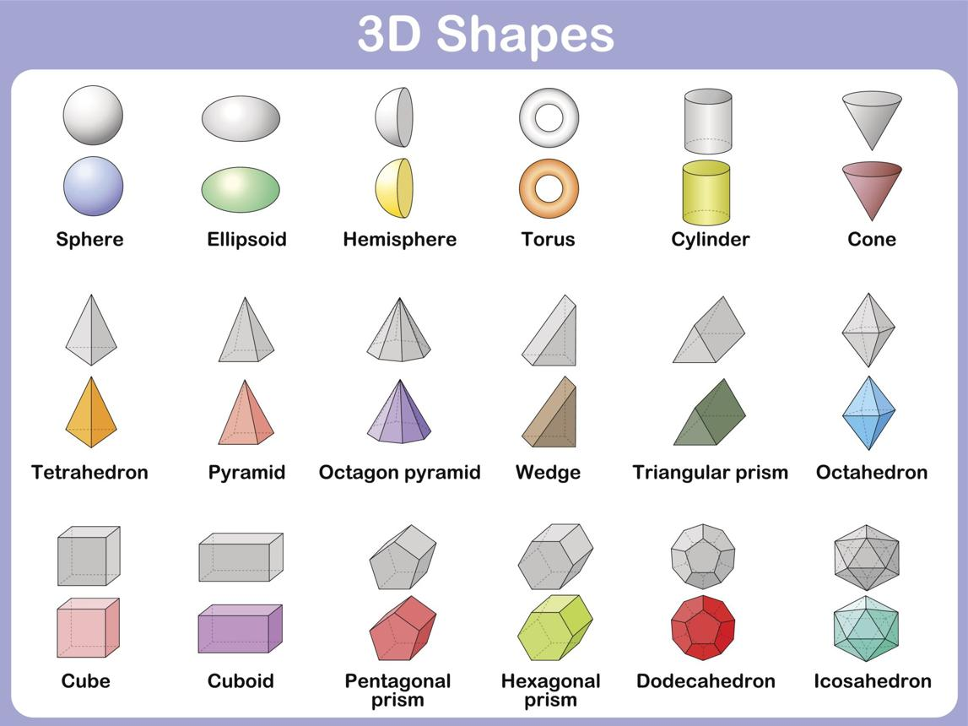
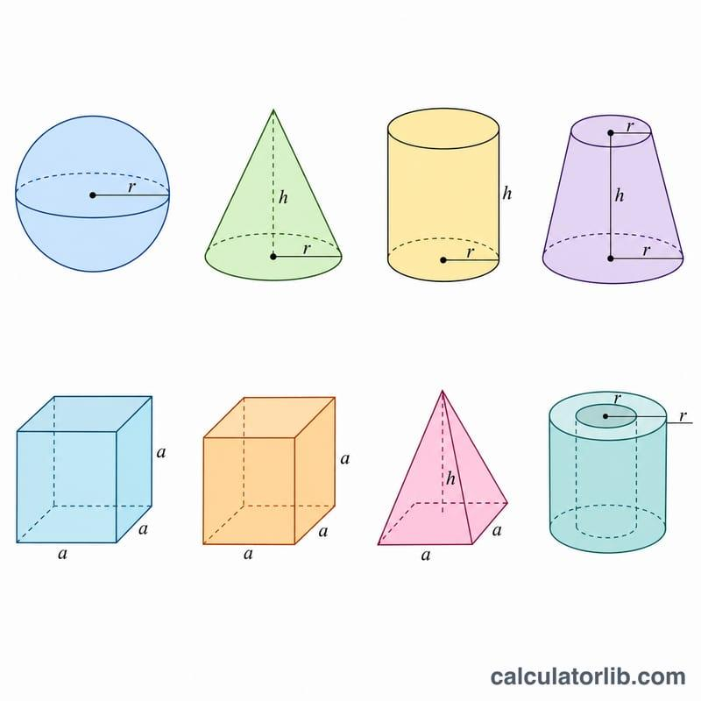
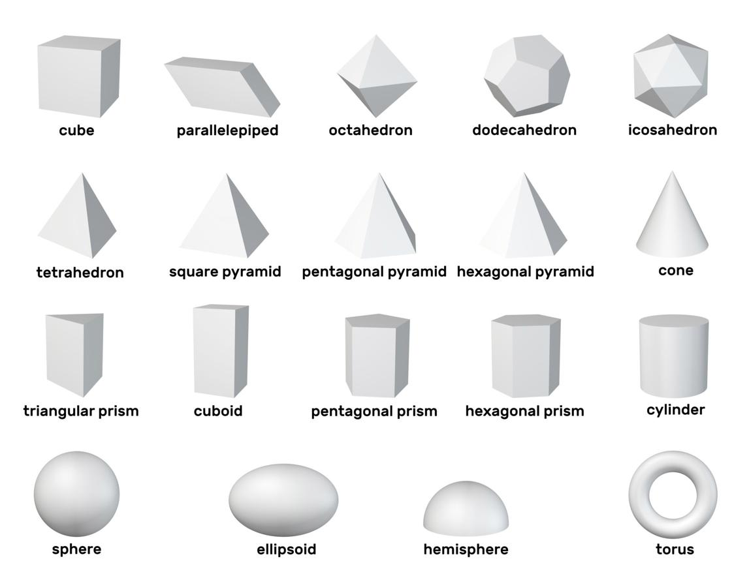
These solids have at least one curved boundary surface.
- Sphere: A solid whose boundary points are all equally distant from its center.
- Cylinder: A solid with two parallel, congruent bases in the right circular case.
- Cone: A solid with a base that narrows to an apex in the circular-cone case.
- Hemisphere: One half of a sphere divided by a plane through its center.
- Ellipsoid: A sphere-like solid that can have different lengths along its principal axes.
- Torus: A ring-shaped solid.

3. Composite Solids
# Source: AI Source: Provided by: [Data Path: Persons Table -> ID Column: 1, Name_En Column: Motasem Essam] -> From: [ChatGPT] on [7/25/2026]
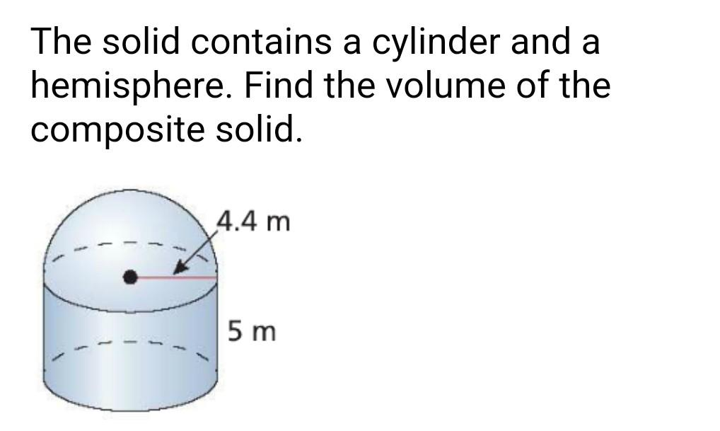
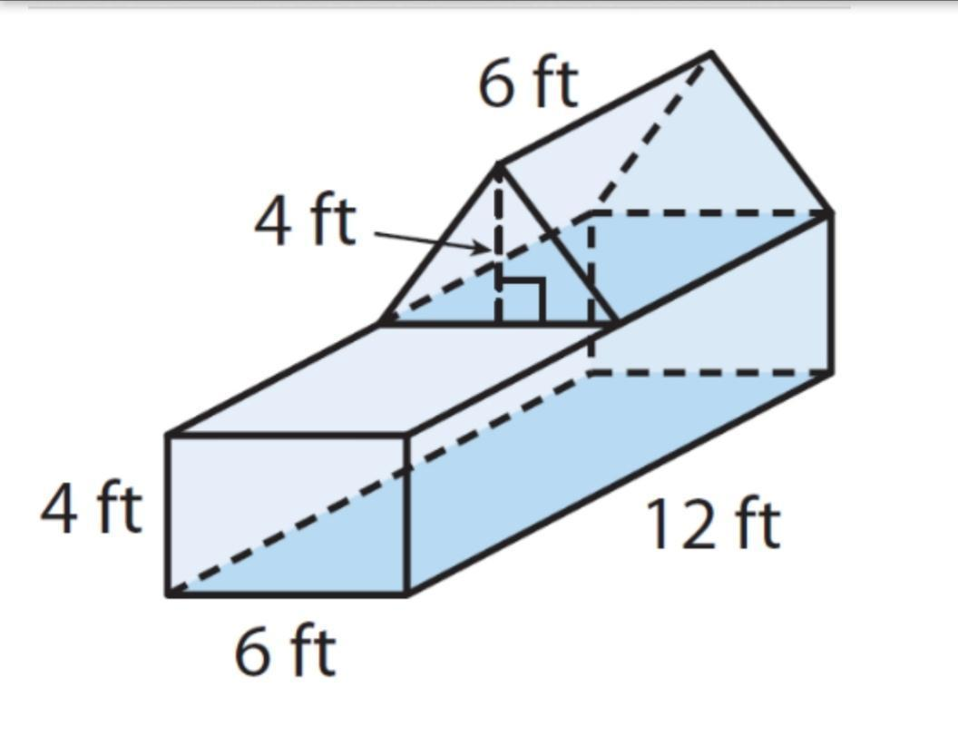
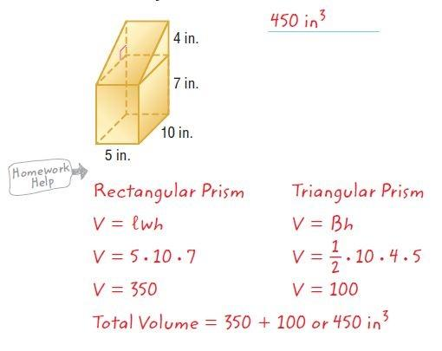
A composite solid is formed by combining or removing simpler solids.
Examples include a cylinder topped by a hemisphere, a building represented by connected cuboids, or a solid formed by subtracting a smaller shape from a larger one.

Elements of a Solid
# Source: AI Source: Provided by: [Data Path: Persons Table -> ID Column: 1, Name_En Column: Motasem Essam] -> From: [ChatGPT] on [7/25/2026]
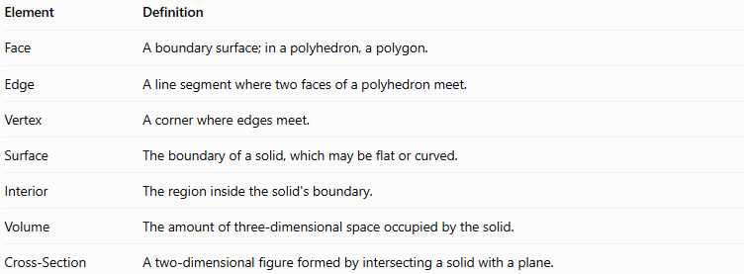
Element | Definition
Face | A boundary surface; in a polyhedron, a polygon.
Edge | A line segment where two faces of a polyhedron meet.
Vertex | A corner where edges meet.
Surface | The boundary of a solid, which may be flat or curved.
Interior | The region inside the solid's boundary.
Volume | The amount of three-dimensional space occupied by the solid.
Cross-Section | A two-dimensional figure formed by intersecting a solid with a plane.
Not every solid has polygonal faces, straight edges, or vertices. For example, a sphere has a curved boundary and no vertices or edges in the usual elementary-geometric sense.

Important Measurements and Formulas
# Source: AI Source: Provided by: [Data Path: Persons Table -> ID Column: 1, Name_En Column: Motasem Essam] -> From: [ChatGPT] on [7/25/2026]
The two principal measurements of a solid are volume and surface area.
Let $a$ be the cube's side length, $l,w,h$ the cuboid's dimensions, $r$ the radius, $B$ the base area, $P$ the base perimeter, and $s$ the slant height where applicable.
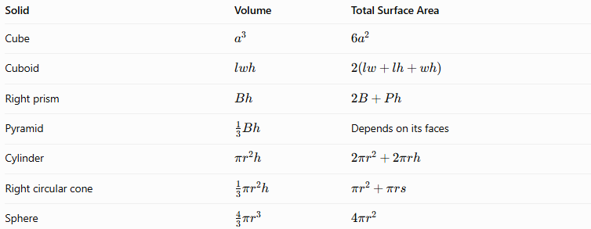
Solid | Volume | Total Surface Area
Cube | $$a^{3}$$ | $$6a^{2}$$
Cuboid | $$lwh$$ | $$2\left(lw+lh+wh\right)$$
Right prism | $$Bh$$ | $$2B+Ph$$
Pyramid | $$\frac{1}{3}Bh$$ | Depends on its faces
Cylinder | $$πr^{2}h$$ | $$2πr^{2}+2πrh$$
Right circular cone | $$\frac{1}{3}πr^{2}h$$ | $$πr^{2}+πrs$$
Sphere | $$\frac{4}{3}πr^{3}$$ | $$4πr^{2}$$
The prism surface-area formula assumes a right prism. The cone formula assumes a right circular cone, with slant height $s=\sqrt{r^{2}+h^{2}}$.
Example: Volume of a Cube
If a cube has side length $4\text{ cm}$,
$$V=a^{3}=4^{3}=\boxed{64{\text{ cm}}^{3}}$$
Its total surface area is
$$SA=6a^{2}=6\left(4^{2}\right)=\boxed{96{\text{ cm}}^{2}}$$

Important Geometric Concepts Related to Solids
# Source: AI Source: Provided by: [Data Path: Persons Table -> ID Column: 1, Name_En Column: Motasem Essam] -> From: [ChatGPT] on [7/25/2026]
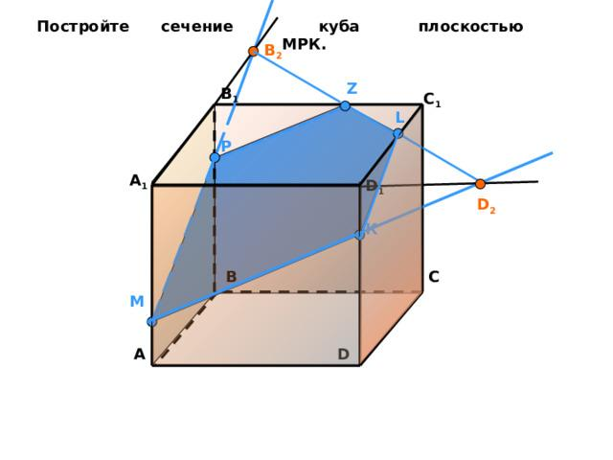
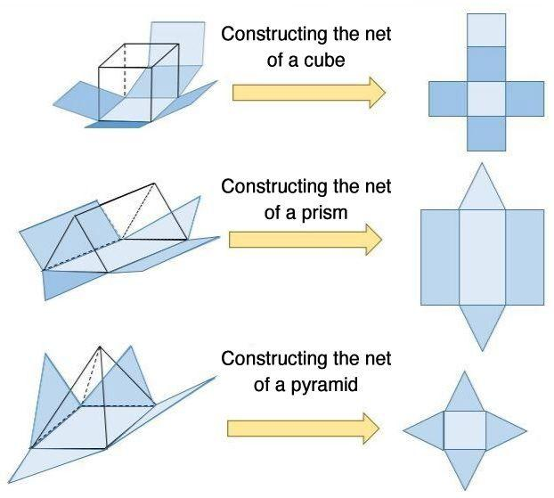
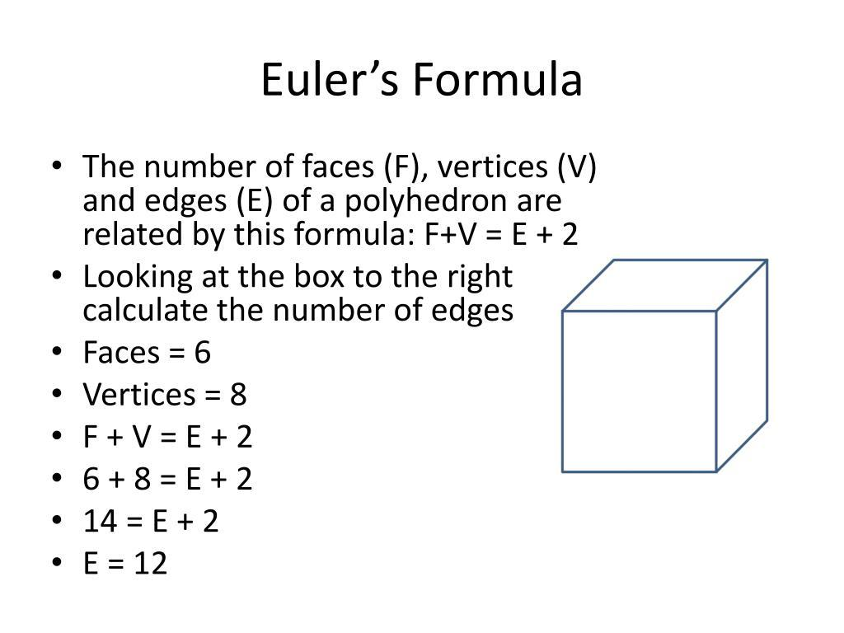
- Cross-Sections: Study the two-dimensional shapes produced when a plane cuts through a solid.
- Nets: Represent the flat arrangement of surfaces that can be folded to form a solid.
- Diagonals: Connect vertices of a solid or its faces.
- Symmetry: Describes transformations that leave a solid unchanged.
- Euler's Polyhedron Formula: For a convex polyhedron, $V-E+F=2$, where $V$ is the number of vertices, $E$ the number of edges, and $F$ the number of faces.
- Spatial Relationships: Describe the positions and orientations of points, lines, and planes relative to a solid.

Solid vs. Surface vs. Plane
# Source: AI Source: Provided by: [Data Path: Persons Table -> ID Column: 1, Name_En Column: Motasem Essam] -> From: [ChatGPT] on [7/25/2026]
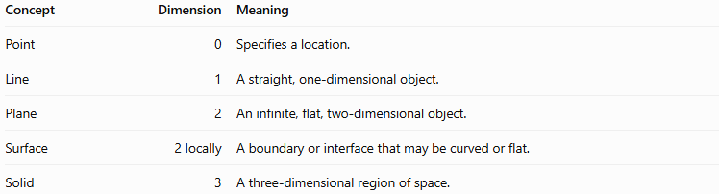
Concept | Dimension | Meaning
Point | 0 | Specifies a location.
Line | 1 | A straight, one-dimensional object.
Plane | 2 | An infinite, flat, two-dimensional object.
Surface | 2 locally | A boundary or interface that may be curved or flat.
Solid | 3 | A three-dimensional region of space.
A solid is not the same as its surface: the solid includes its interior, while its surface is its boundary.

Constructing Solid in Solid Geometry

Instruments Used
# Source: AI Source: Provided by: [Data Path: Persons Table -> ID Column: 1, Name_En Column: Motasem Essam] -> From: [ChatGPT] on [7/25/2026]
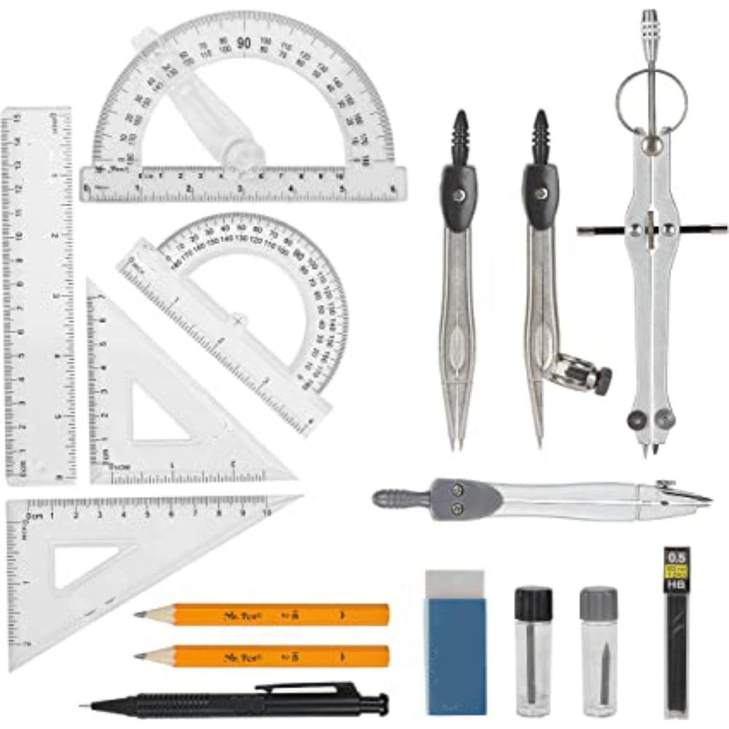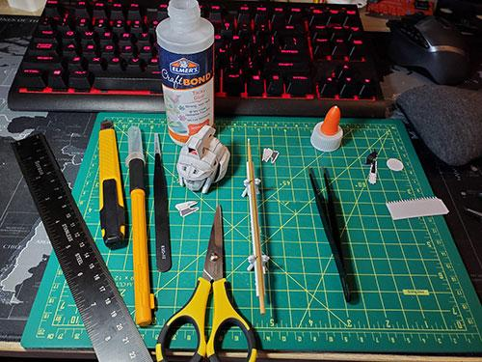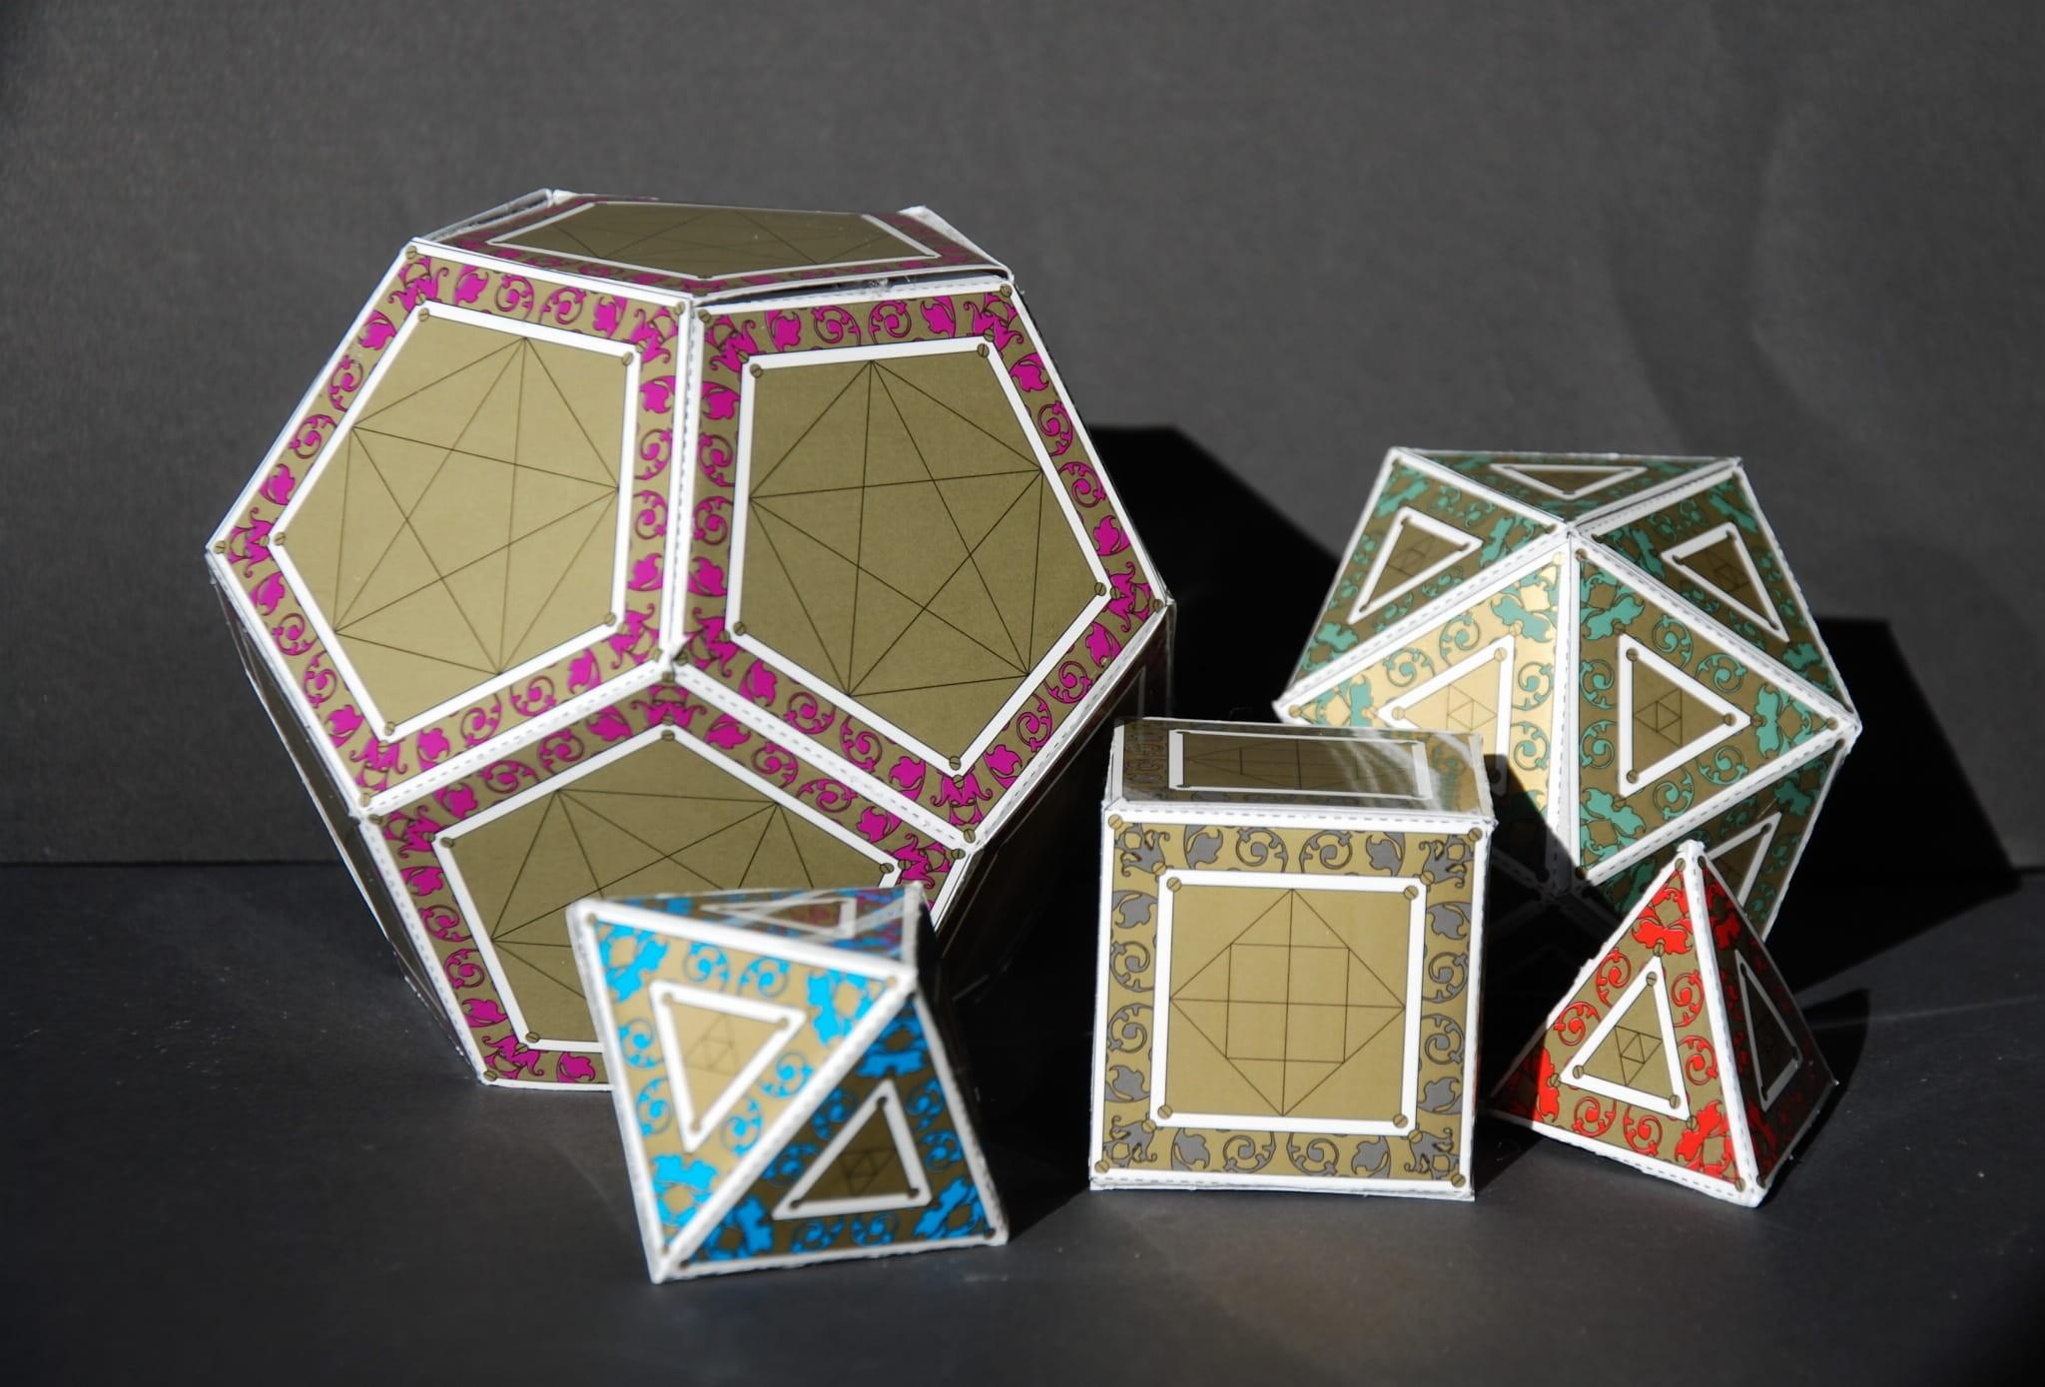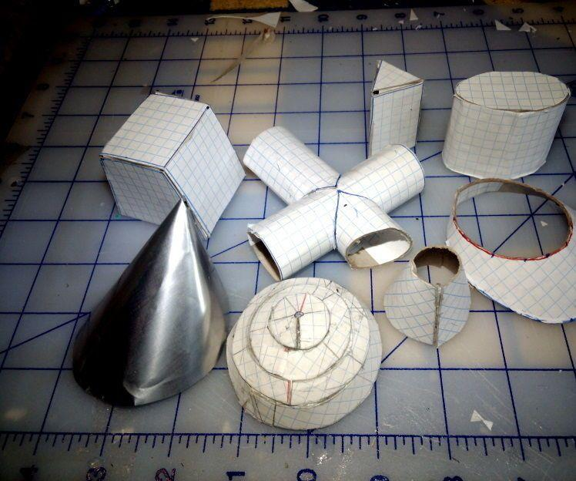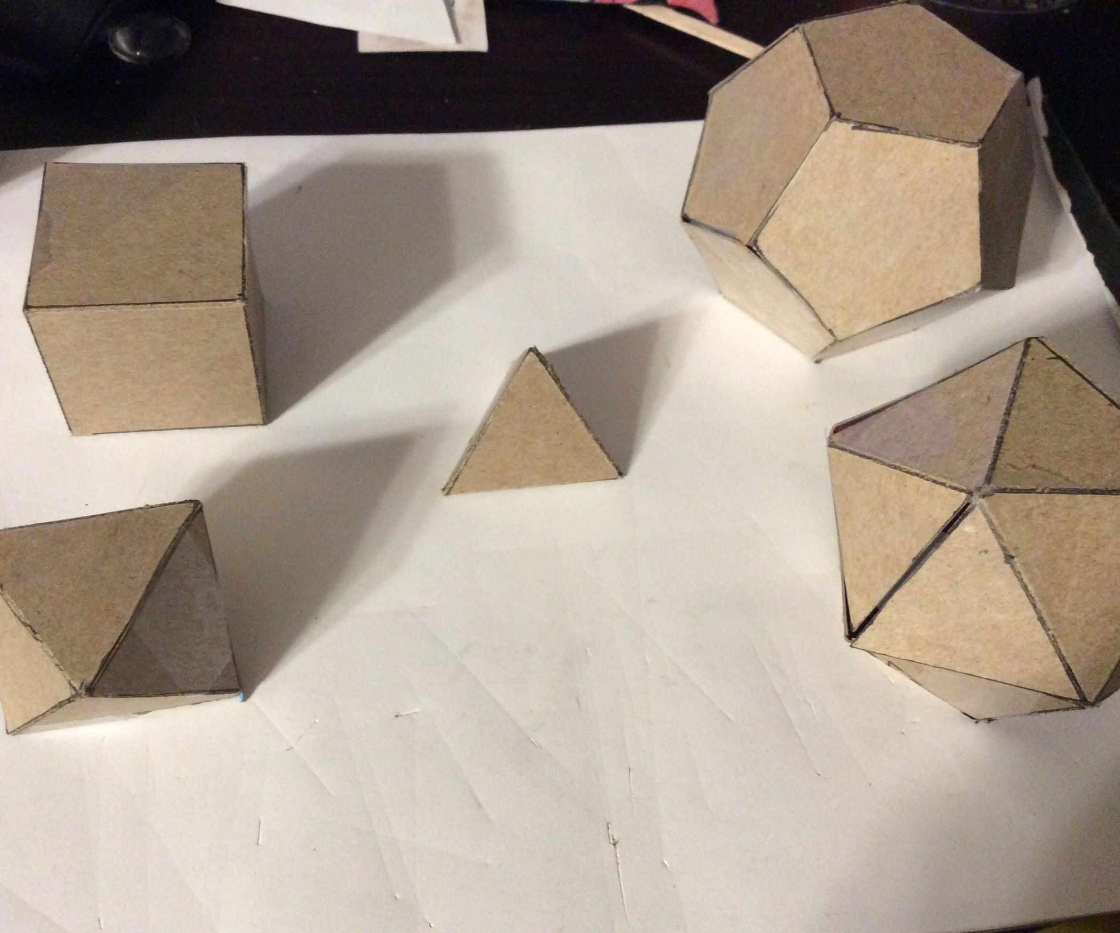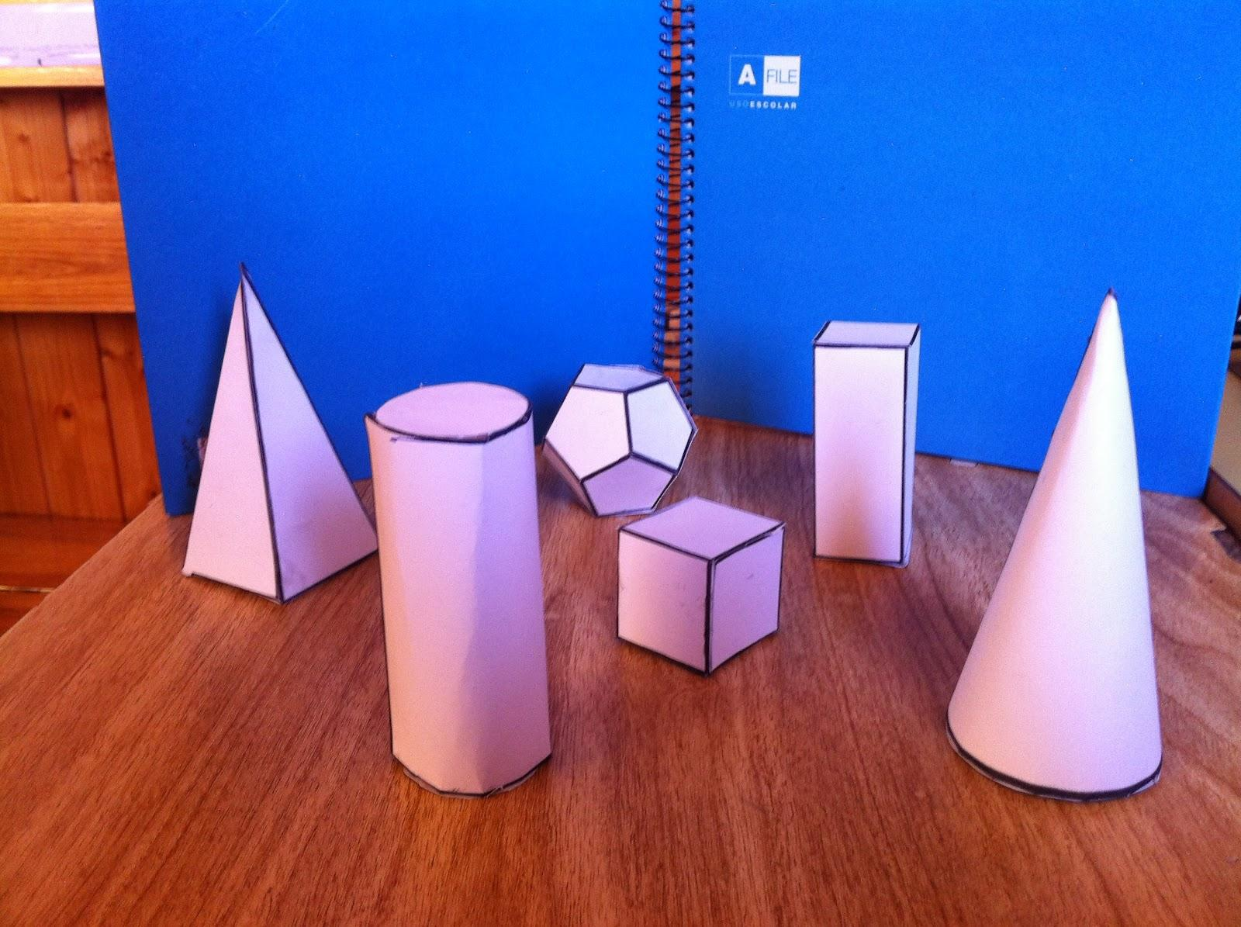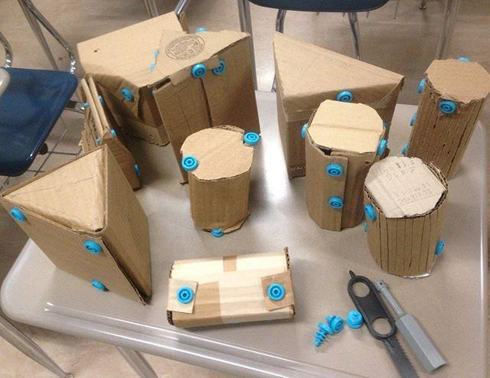
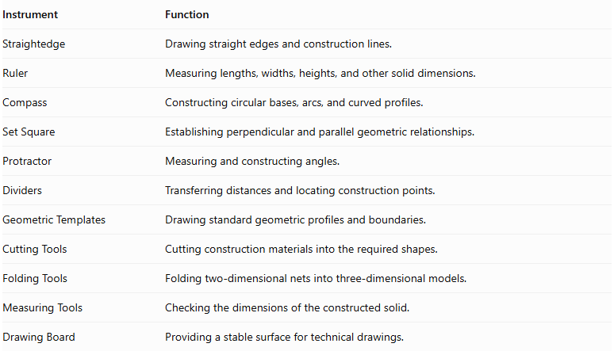
Instrument | Function
Straightedge | Drawing straight edges and construction lines.
Ruler | Measuring lengths, widths, heights, and other solid dimensions.
Compass | Constructing circular bases, arcs, and curved profiles.
Set Square | Establishing perpendicular and parallel geometric relationships.
Protractor | Measuring and constructing angles.
Dividers | Transferring distances and locating construction points.
Geometric Templates | Drawing standard geometric profiles and boundaries.
Cutting Tools | Cutting construction materials into the required shapes.
Folding Tools | Folding two-dimensional nets into three-dimensional models.
Measuring Tools | Checking the dimensions of the constructed solid.
Drawing Board | Providing a stable surface for technical drawings.

Construction Procedures

Constructing a Polyhedron Using Faces, Edges, and Vertices
# Source: AI Source: Provided by: [Data Path: Persons Table -> ID Column: 1, Name_En Column: Motasem Essam] -> From: [ChatGPT] on [7/25/2026]
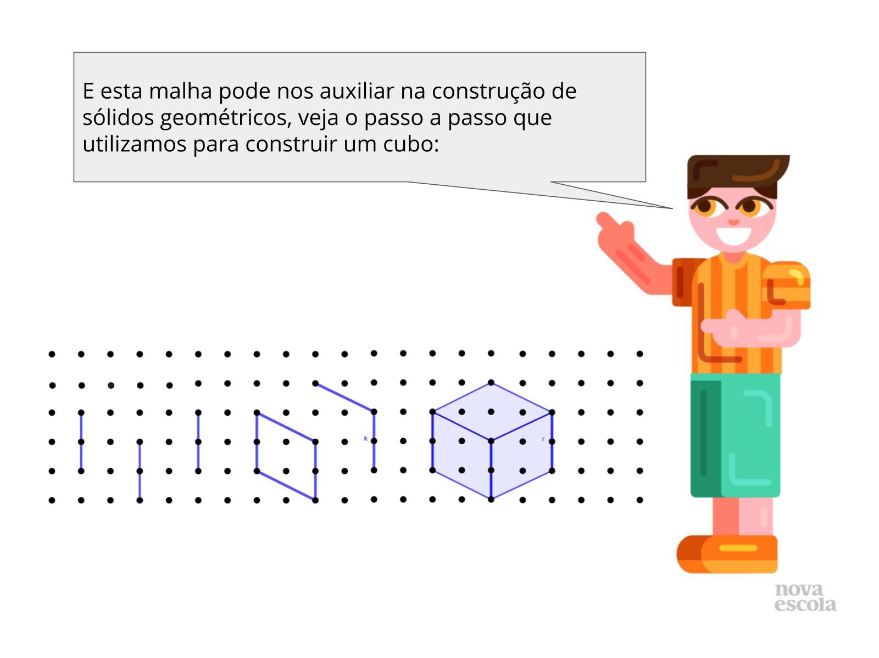
- Determine the required polyhedron.
- Identify the shapes and number of its faces.
- Determine the positions of its vertices.
- Connect the vertices using straight line segments to establish the edges.
- Construct the polygonal faces.
- Join the faces according to their required arrangement.
- Verify that the resulting boundary forms the intended solid.

Constructing a Solid Using a Net
# Source: AI Source: Provided by: [Data Path: Persons Table -> ID Column: 1, Name_En Column: Motasem Essam] -> From: [ChatGPT] on [7/25/2026]
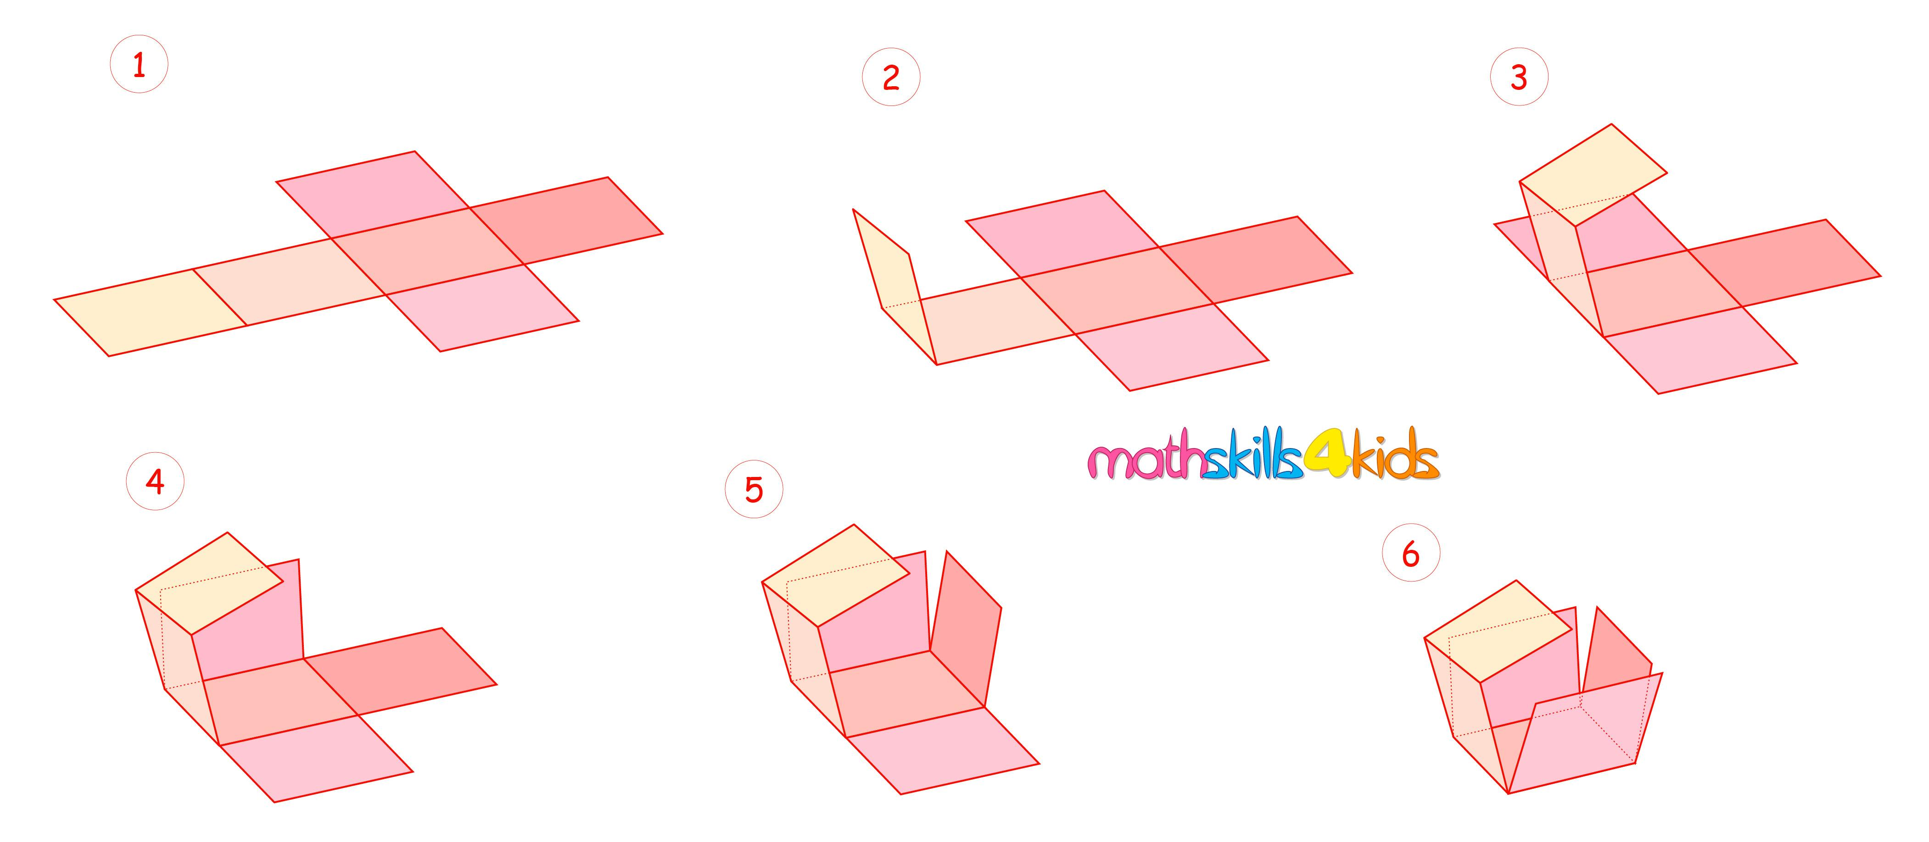
- Determine the solid to be constructed.
- Identify the shape and number of its faces.
- Arrange the faces in a connected two-dimensional net.
- Draw the net using a ruler and other appropriate instruments.
- Cut out the net if constructing a physical model.
- Fold along the designated edges.
- Join the corresponding faces.
- Verify that the resulting model forms the intended solid.

Constructing a Prism by Extrusion
# Source: AI Source: Provided by: [Data Path: Persons Table -> ID Column: 1, Name_En Column: Motasem Essam] -> From: [ChatGPT] on [7/25/2026]
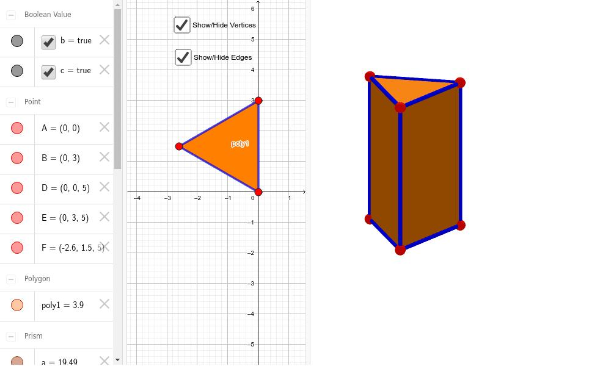
- Construct the required polygonal base.
- Determine the extrusion direction and length.
- Establish corresponding points at the other end.
- Connect corresponding vertices using straight line segments.
- Construct the second base.
- Complete the lateral faces.
- Verify the dimensions and structure of the prism.

Constructing a Pyramid
# Source: AI Source: Provided by: [Data Path: Persons Table -> ID Column: 1, Name_En Column: Motasem Essam] -> From: [ChatGPT] on [7/25/2026]
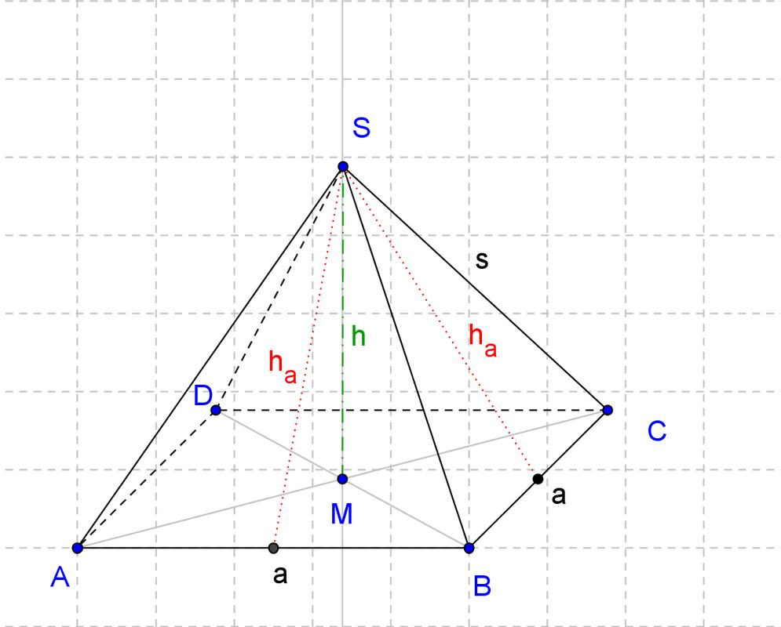
- Construct the polygonal base.
- Determine the position of the apex.
- Connect the apex to each vertex of the base.
- Construct the triangular lateral faces.
- Complete the boundary of the pyramid.
- Verify the position of the apex and the base dimensions.

Constructing a Solid of Revolution
# Source: AI Source: Provided by: [Data Path: Persons Table -> ID Column: 1, Name_En Column: Motasem Essam] -> From: [ChatGPT] on [7/25/2026]
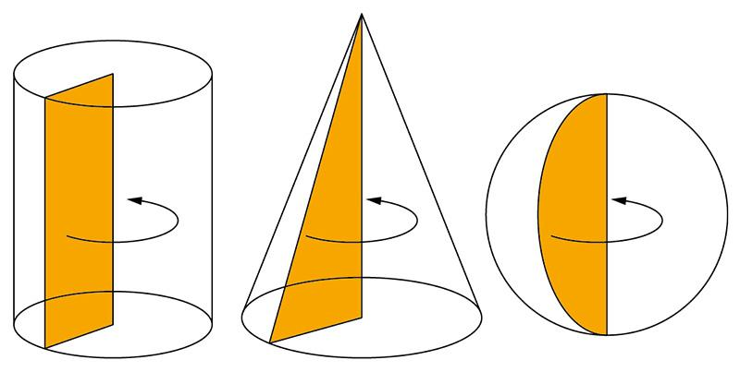
- Draw the generating planar region.
- Establish the axis of revolution.
- Determine the rotational relationship between the region and the axis.
- Represent successive rotational positions of the region.
- Complete the resulting three-dimensional boundary.
- Identify the generated solid.

Constructing a Solid by Addition
# Source: AI Source: Provided by: [Data Path: Persons Table -> ID Column: 1, Name_En Column: Motasem Essam] -> From: [ChatGPT] on [7/25/2026]
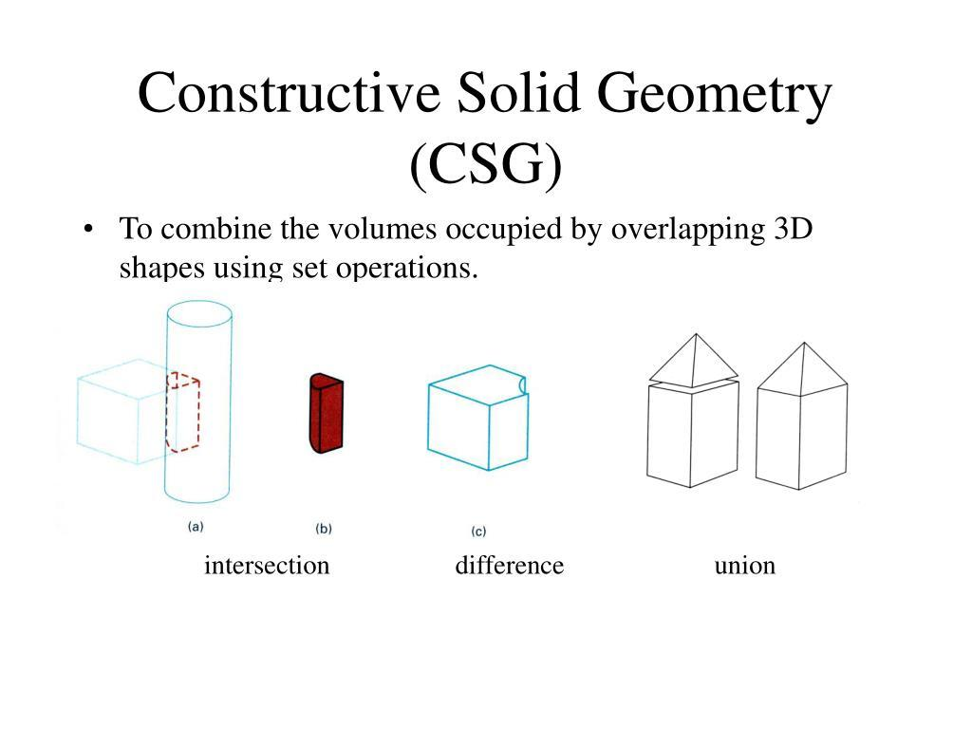
- Identify the required component solids.
- Construct each component separately.
- Determine their relative positions and orientations.
- Bring the components together along the required faces or regions.
- Join the components.
- Remove internal boundaries that do not belong to the exterior boundary of the combined solid.
- Verify the resulting composite solid.

Constructing a Solid by Subtraction
# Source: AI Source: Provided by: [Data Path: Persons Table -> ID Column: 1, Name_En Column: Motasem Essam] -> From: [ChatGPT] on [7/25/2026]
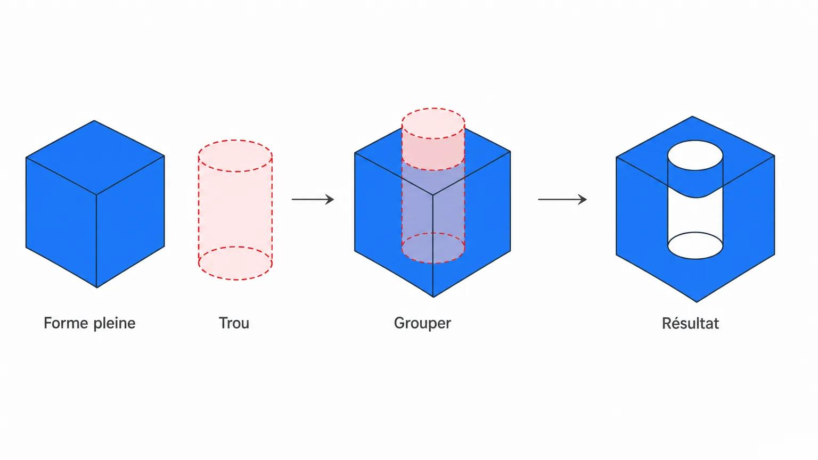
- Construct the original solid.
- Construct the solid portion to be removed.
- Determine the position and orientation of the cutting component.
- Identify the volume that must be removed.
- Represent the resulting boundary after subtraction.
- Verify the shape and remaining volume of the solid.

Constructing a Solid Using Cross Sections
# Source: AI Source: Provided by: [Data Path: Persons Table -> ID Column: 1, Name_En Column: Motasem Essam] -> From: [ChatGPT] on [7/25/2026]
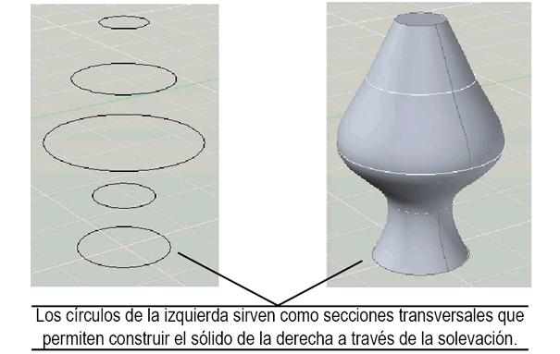
- Determine the required solid shape.
- Establish the cross-sectional planes.
- Construct the required profiles in those planes.
- Determine corresponding points between successive profiles.
- Connect the profiles to form the surface boundary.
- Complete the end surfaces where required.
- Verify the resulting solid.

Applications of Solids
# Source: AI Source: Provided by: [Data Path: Persons Table -> ID Column: 1, Name_En Column: Motasem Essam] -> From: [ChatGPT] on [7/25/2026]
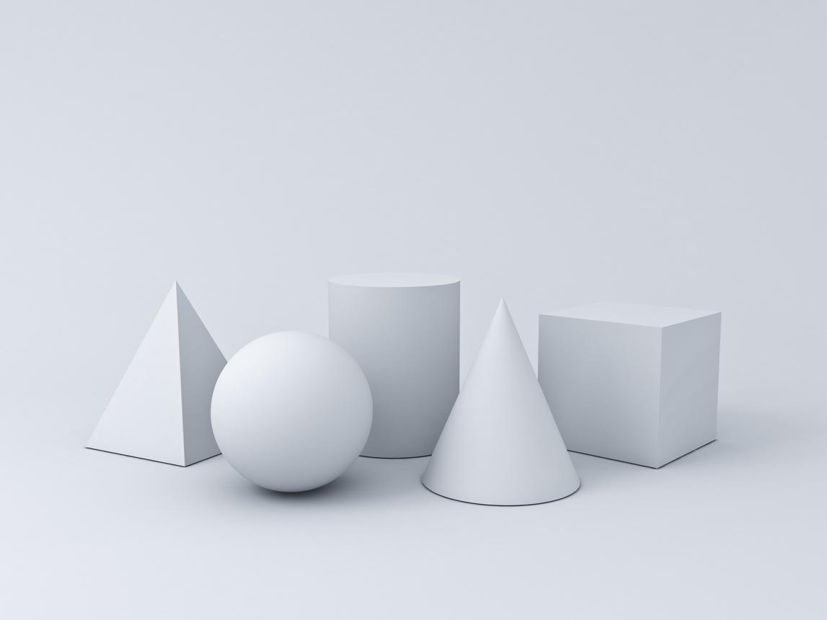
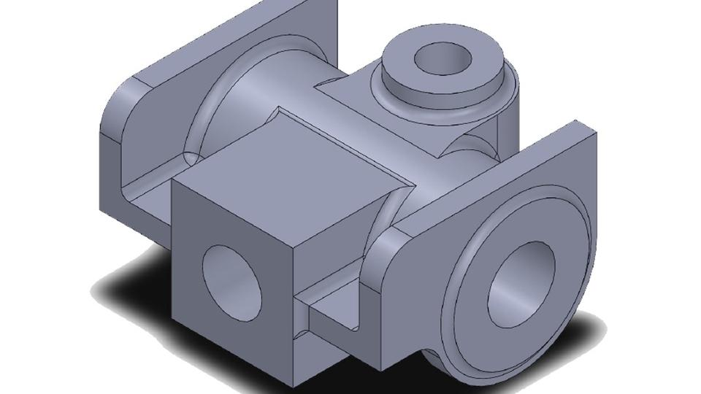
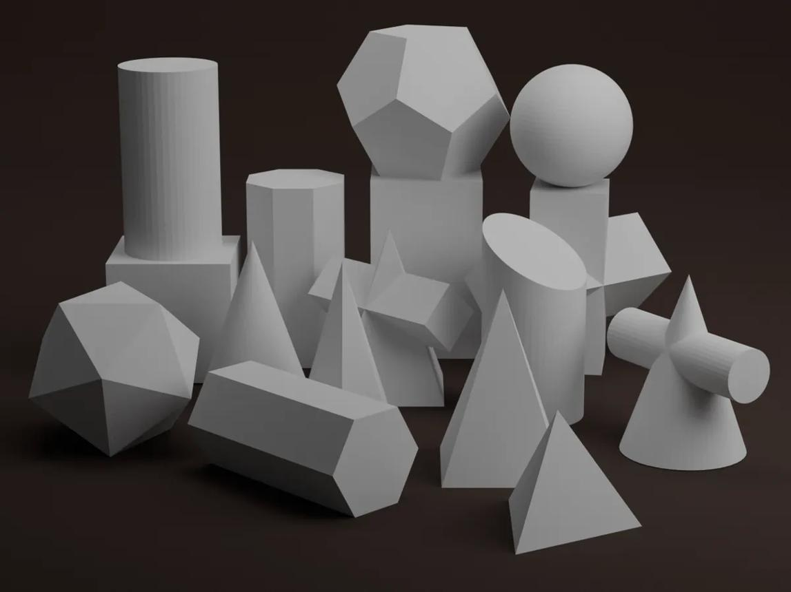
Solids are used in:
- Architecture: Designing buildings and estimating material requirements.
- Engineering: Modeling mechanical parts and calculating dimensions.
- Manufacturing: Designing objects for production.
- Packaging: Determining container capacity and material usage.
- Physics: Representing objects that occupy physical space.
- Computer Graphics: Creating three-dimensional models and rendered scenes.

Key Points
# Source: AI Source: Provided by: [Data Path: Persons Table -> ID Column: 1, Name_En Column: Motasem Essam] -> From: [ChatGPT] on [7/25/2026]
- A solid is a three-dimensional geometric object or region that occupies space.
- Solids may have flat faces, curved surfaces, or both.
- Polyhedra, curved solids, and composite solids are important categories.
- Volume measures the space occupied by a solid, while surface area measures its boundary.
- Faces, edges, vertices, surfaces, and cross-sections help describe and analyze solids.
- Solid Geometry provides the foundation for many applications in mathematics, architecture, engineering, and computer graphics.

Conclusion
# Source: AI Source: Provided by: [Data Path: Persons Table -> ID Column: 1, Name_En Column: Motasem Essam] -> From: [ChatGPT] on [7/25/2026]
A Solid in Solid Geometry is a fundamental three-dimensional geometric object that occupies a region of space and is studied through its shape, dimensions, boundary, volume, and surface area. Solids may be bounded by flat polygonal faces, curved surfaces, or combinations of different geometric forms.
Understanding solids provides the foundation for studying polyhedra, spheres, cylinders, cones, composite objects, and spatial relationships. It also connects abstract geometry to practical problems involving measurement, construction, design, and three-dimensional modeling.

